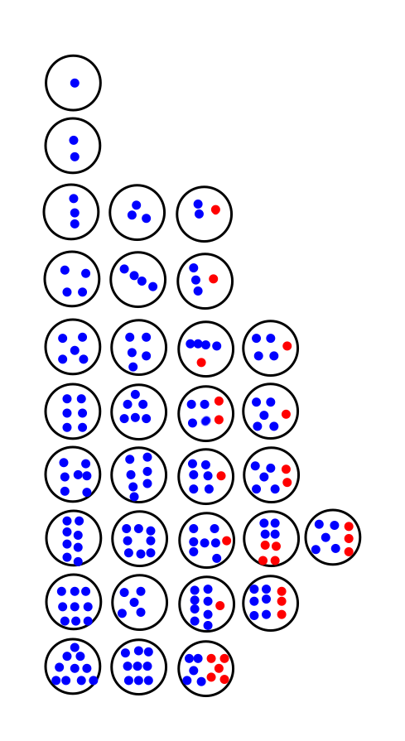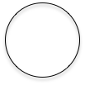

Dot Card Configurations: See *Elementary and Middle School Mathematics: Teaching Developmentally*, John A. Van De Walle (page 126)